Create the bar code

For example, in bar code we are putting mobile number

https://goqr.me/api/

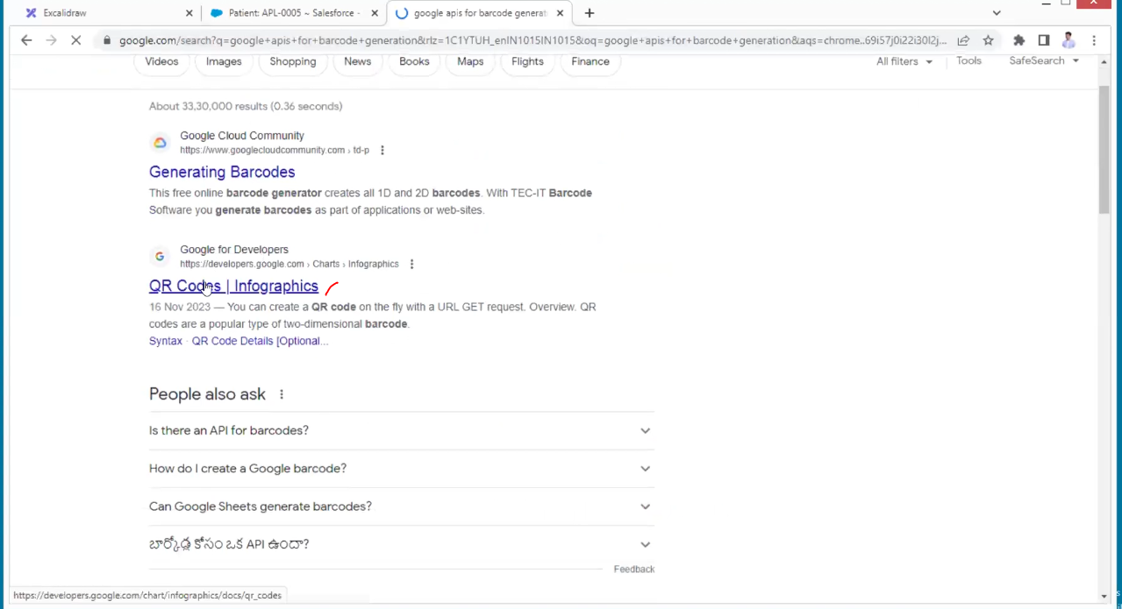

After the URL add cht=qr

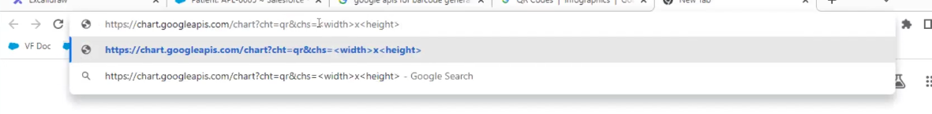

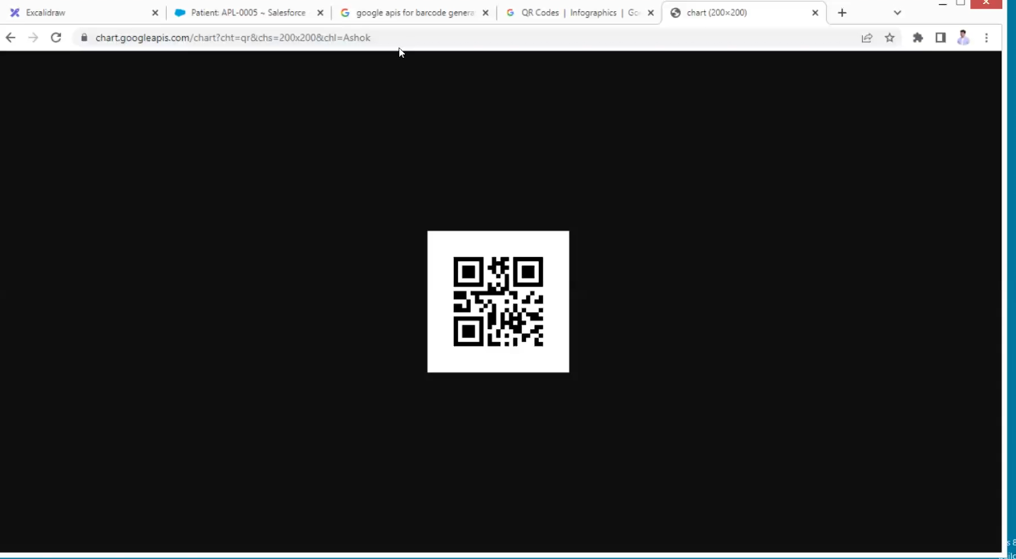

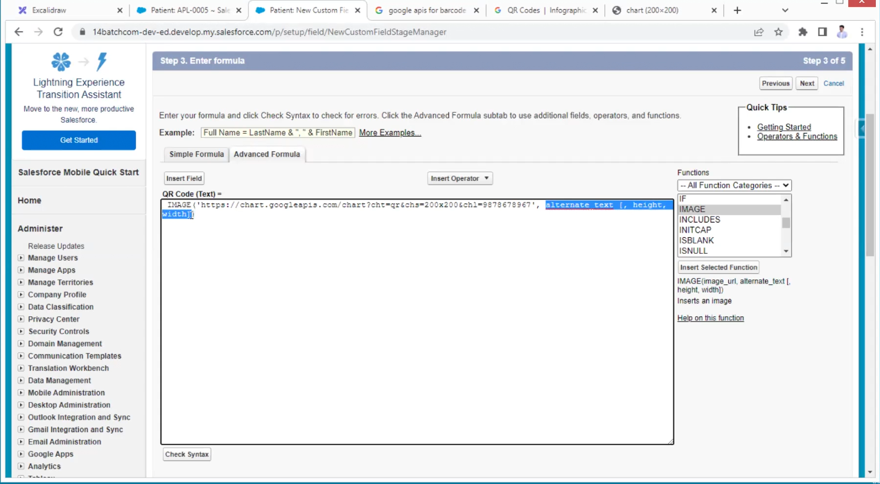

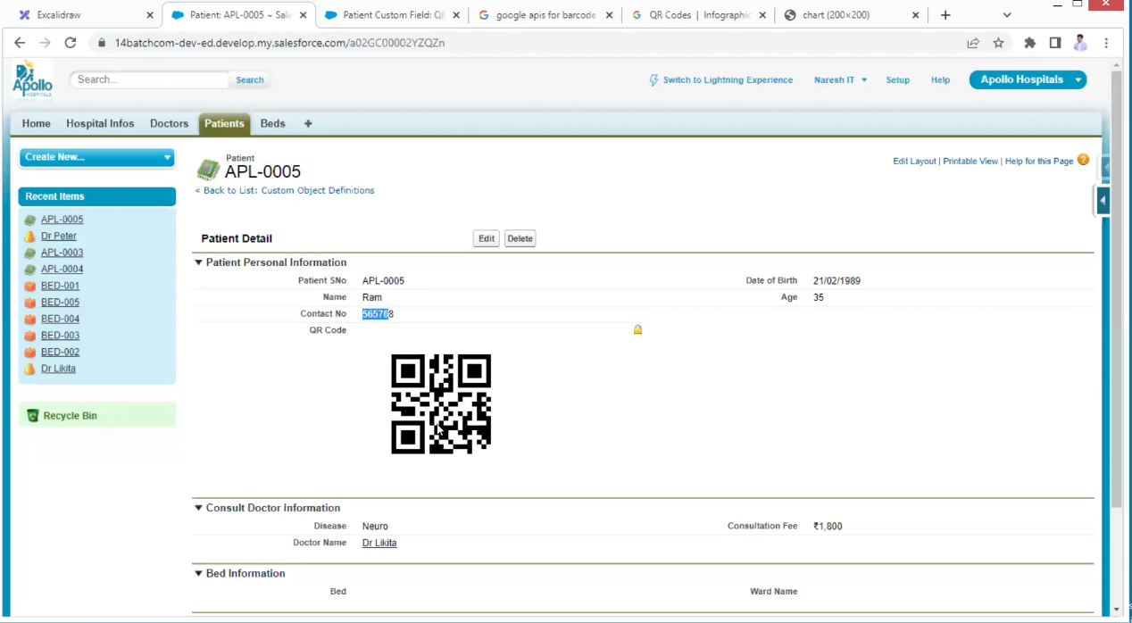

In this case we are getting only static data of single number if change number if scan we are getting old number

We need dynamic data

One-to-one relation (one patient, one doctor)

One to many (one doctor many patients)

Many to many (one hospital many patients, one doctor many patients mean hospital is indirectly connected to doctors-patient point of view doctor is mandatory relationship and hospital also mandatory relationship)

In the above case, a patient object is a junction object which can hold two master relationships or two parents

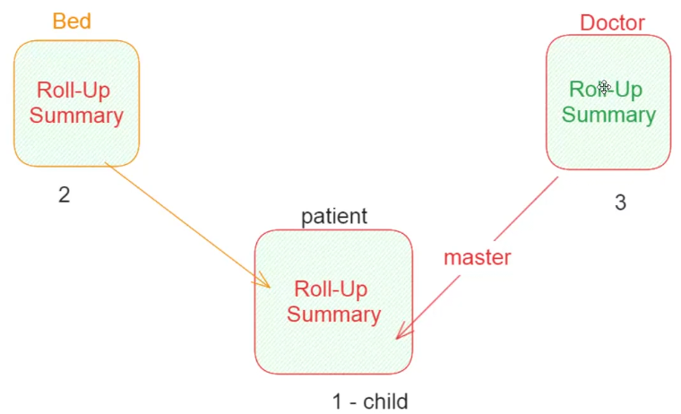

From page layouts

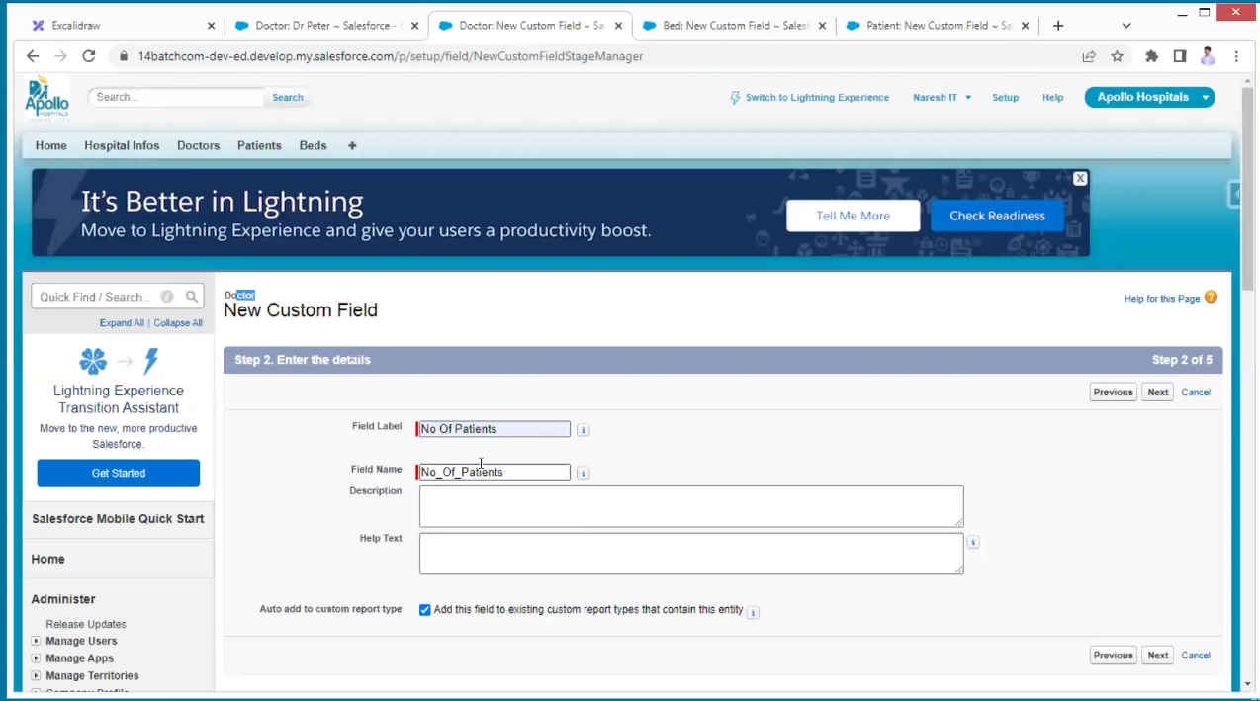

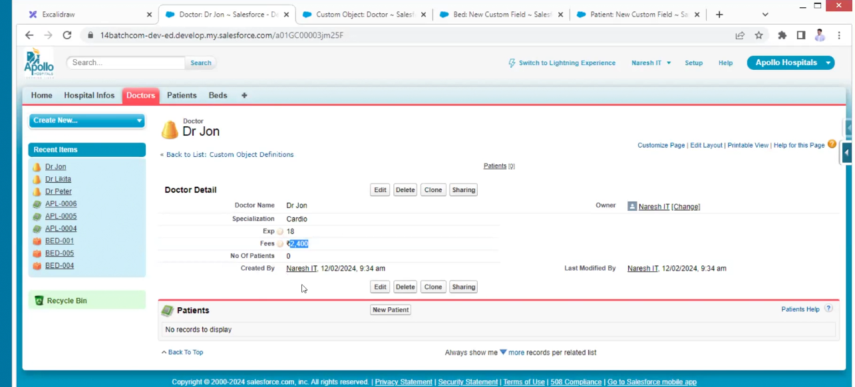



Doctor is taking 40% of fee

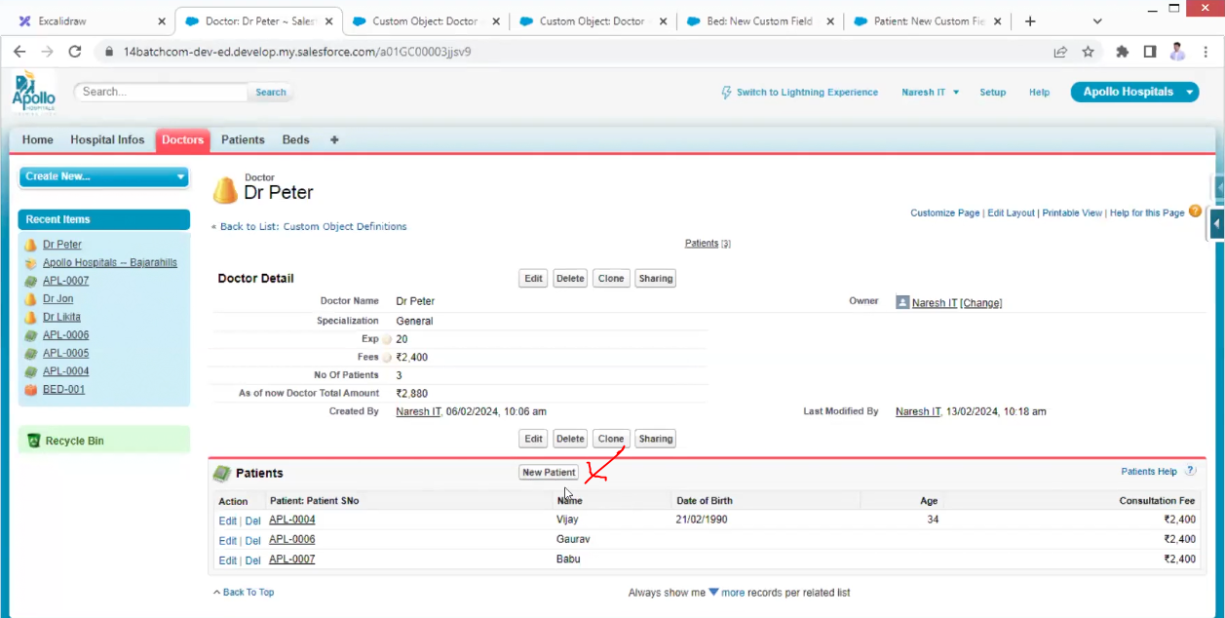

Remove button

Roll-up summary does not work for formulae fields

